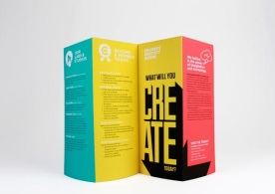
Brochure Assignment
You will be creating a trifold brochure for one of the Health Related Fitness Component. This brochure would be used to explain the importance of this particular component. Below you will find the information necessary for the assignment. Once the brochure is completed, please print it out and turn it in to your teacher.

Panel #1: Title (Ex: Health Related Fitness Components)
Title of your brochure
Picture representing your Component

Panel #2: Definition of the Component
Title of the Panel
Benefits of the component (at least 3)
Picture representing the component

Panel #3: One FitnessGram Assessment that is used to assess
this particular Component
Picture representing the FitnessGram Assessment
Directions on how to appropriately complete this
Assessment

Panel #4: A Second FitnessGram Assessment that is used to assess
this particular Component
Picture representing the FitnessGram Assessment
Directions on how to appropriately complete this
Assessment

Panel #5: Illnesses/Diseases prevented by this component
Picture representing the illnesses/diseases

Panel #6: Personal Information: Student’s name (first and last)
Places you can go for more information on this component
Sources you used to create this brochure
Date brochure was completed & Teacher’s name

